GCSE Media
Case Study and Exam Question Revision Booklet
https://www.ocr.org.uk/Images/316659-specification-accredited-gcse-media-studies-j200.pdf
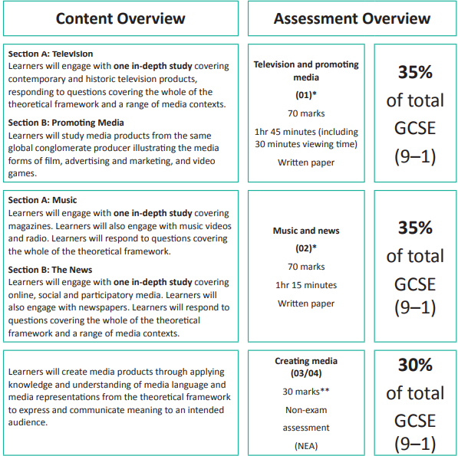

Paper 1: Televison and promoting Media
Section A – Television
- You need to know The Avengers ‘The Town of No Return’ (ITV Saturdays 1965 9.05pm)
- You need to know Cuffs ‘The Luck of the Draw’ (BBC 1 Wednesdays 2015 8pm)
- Social and historical contexts of 1960s and 2010s

Section B – Promoting Media
  - You need to know the set posters for The Lego movie
  - You need to know the set trailer for The Lego Movie – this is ALL the adverts made of Lego that we have watched
  - You need to know why Lego released a video game linked to the movie and what pleasures it offers the audience ( Blumer and Katz )

Paper 2: Music and News
Section A – Music
- MOJO magazine and its conventions
- Music magazine conventions generally (make sure you know that different genres of music would have slightly different conventions on their covers)
- Mark Ronson’s ‘Uptown Funk’ and Beyonce’s ‘If I were a boy’
- Radio 1- you need to know about the BBC and its remit, facts about scheduling and how and why they target audiences, with particular reference to the Live Lounge ( presented by Clara Amfo since 2015 in her mid-morning show. Refer to any British artist who has appeared 2017 onwards)

Section B – News
- The Observer historical covers from 1960s- you need to know at least three things which were on any of the covers
- Social/historical context of 1960s
- The Observer – you need to know at least one modern cover but have good understanding of the typical conventions on the covers and what news stories it runs
- You need to know the typical reader of the modern Observer and the newspaper’s values
- You need to know the conventions of The Observer online and how the online version is similar to the printed paper

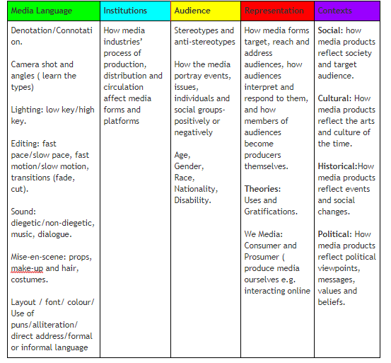
Remember all Media Language for each Media text we have studied.

Make cue cards on all the types of factual STATE questions you may get
What is meant by Public Service Broadcasting? Use the BBC as your example.
In the United Kingdom, the term "public service broadcasting" refers to broadcasting intended for public benefit rather than to serve purely commercial interests.
Which company produced and distributed The Lego Movie Game?
TT Fusion
Who regulates the film industry?
The BBFC
What is a tent-pole film?
it is expected to make large profits in order to support funding of other projects
What do we mean by genre hybridity?
A mixture of genres
Identify the owner of MOJO magazine
Bauer Media
Identify the regulator for radio
OFCOM
The owner of MOJO also owns radio stations.
Identify the term for branching out into other areas of business
Diversification
Give one example of a mass audience radio station
BBC Radio 2 or 4
Give one example of a niche audience radio station
BBC Radio 1Xtra, BBC 3, Any local Radio Station
Name the media industry's term for bringing together different platforms.
Convergence
Name two different platforms that deliver the Radio One Live Lounge
Radio 1 BBC 4 BBC iPlayer YouTube
List 4 ways a Radio station might offer uses and gratifications
Personal Identity/ Entertainment/ Surveillance
State two generic conventions of music videos
Performance to camera, fast paced editing or setting /location to express meaning
State two forms a music video might take
Performance or Narrative
Which term describes a mixing of styles and genres in a music video?
Hybridity
State how British magazines are globalised
By being owned by international publishers based in the USA and Germany
Explain how Bauer Media is diversified
It owns radio and TV stations as well to spread the risk of just owning magazines
State two ways a print magazine can gain revenue
Cover price, advertising, sponsored content, product placement, associated activities such as events
State one audience category that is more likely to read MOJO
Men
Define intertextuality
References to other media products which the audience are expected to recognise
Define genre hybridity
A media product which combines a number of different genres
Identify the owner of The Observer
Guardian Media Group or the Scott Trust
Identify one regulator for newspapers
IPSO or IMPRESS
Audiences can read newspapers online using a tablet, computer or a mobile phone. What is the term for this use of different platforms for the same content?
Convergence
A newspaper which offers soft news aimed at a downmarket audience- tabloid or broadsheet?
Tabloid
State 2 demographics for typical online Observer readers (class and gender)
Middle class ( AB or AB1) and male
State one way that newspaper owners explicitly exercise control over their newspapers
By appointing an editor with opinions similar to their own

Section A – Television
Use this grid to create notes on ‘Cuffs’ and ‘The Avengers’
The Avengers Background Information |  | Cuffs Background Information
Characters in The Avengers
Characters in Cuffs
Facts about BBC and ITV

PSB =

What and how do the channels target audiences:

Sound terms and eg | Camera terms and eg | Mise-en-scene terms and eg | Editing terms and eg

Exam Style Questions

Choose either Cuffs or a The Avengers.
How do social contexts influence television programmes
[10 marks]

Introduction
Outline your understanding of the context at the time the programme aired
Paragraph 1 –example from text e.g. gender beliefs at the time and how the characters are represented
Paragraph 2 –
e.g the types of crimes which occur and why these link to social beliefs at the time

or sexuality or patriarchal society or race representation
Conclusion
State your overall judgement of how Cuffs/The Avengers fits the time it was set

Section B – Promoting Media
Use this grid to create notes on The Lego Movie marketing Campaign

The Lego Movie campaign | Who’s who?  Emmet  Vitruvius  Wyldstyle  Lord Business  Batman  Are they stereotypes?
Background Information:

Warner Bros
Tent Pole film
Game released on many different platforms
Trailer uses familiar adverts but recreates them in Lego

Why release a video game linked to the film?
List 4 points:

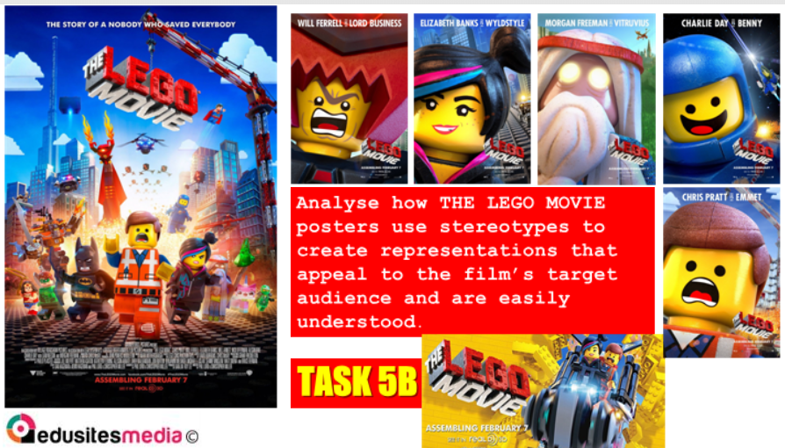

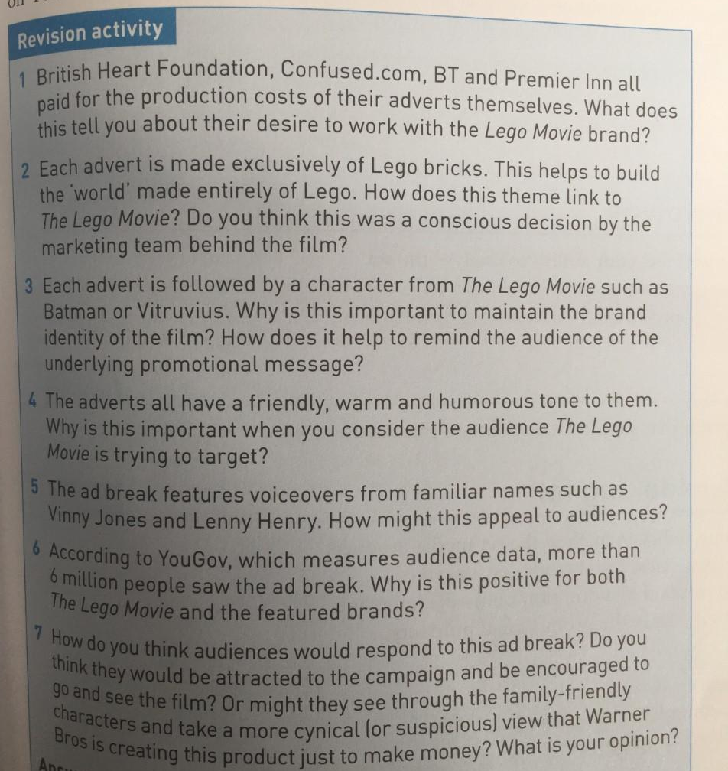

Who is the primary and secondary audience?

Analyse the representations of gender in the Lego Movie trailer [10 marks]

Paper 2: Section A – Music
Use this grid to create notes on MOJO
MOJO – any cover after September 2017  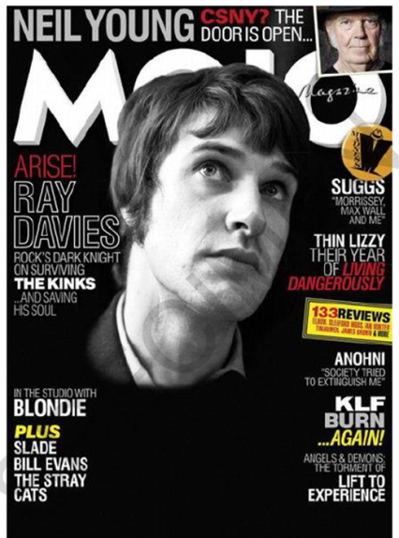 |  | Typical conventions of music magazine:
MOJO facts (e.g. /owner/convergence examples)

Typical reader of MOJO:
Cover examples:
Gender | Colours | How stories presented in coverlines | How we know it is a rock magazine
Hint: Have I used the word stereotype or anti-stereotype?

Explain one way MOJO magazine uses media language to appeal to its target audience.
[4 marks]

Section A: Music Use this grid to create notes on music videos:
Mark Ronson ‘Uptown Funk’  Beyonce ‘If I Were A Boy’ |  | The set Music videos:  Similarities:  Differences:
Background Information of bands

Mark Ronson

Beyonce

Typical viewer of these videos:
Video examples:
Gender  Mark Ronson  Beyonce | Race  Mark Ronson  Beyonce | Narrative or performance and why  Mark Ronson  Beyonce | My examples from videos of:  Setting  Costume  Camera shots/angles  Editing
Hint: Have I used the word stereotype or anti-stereotype?
Mark Ronson – typical story? Why on streets? |  | Beyonce – Why has she chosen gender role reversal?

Exam Style Question Use 1 examples of how the music videos use gender sterotypes to appeal to their audiences
[4 marks]
Introduction

Paragraph 1 –

Section A: Music Use this grid to create notes on BBC Radio 1 and the Live Lounge :

BBC Radio One – PSB- Live Lounge on mid-morning presented by Clara Amfo
Background Information of BBC and PSB

Typical listener of Radio 1:
Radio examples:
Presenter: | Website: | Typical artist and what they do in performance: | Convergence?  ( other ways to access the Radio other than physical radio in kitchen)
Hint: Have I used the word stereotype or anti-stereotype? Can I link to why these things are done?
Notes: |  | Notes:

Exam Style Question Explain how Radio 1’s Live Lounge fits the PSB requirements?
[10 marks]
Introduction

Paragraph 1 –

Paragraph 2 –

Section B: News Use this grid to create notes on The Observer:

The Observer 30 October 1966  The Observer 6 November 1966  The Observer 20 October 1968 |  | Values of The Observer
Background Information of 1960s

Typical reader of The Observer:
Cover examples:
Gender | Race | Formality of how stories presented | Politics or international news
Hint: Have I used the word stereotype or anti-stereotype?
Modern Print The Observer – typical story? |  | Online Observer- what features are the same as the printed paper?

Exam Style Question Use 3 examples of how the 1960s Observer reflects the social /political/cultural beliefs of the time
[10 marks]
Introduction
Outline your understanding of the content.
State your initial opinion.
Paragraph 1 –

Paragraph 2 -

Conclusion
State your overall judgement using the evidence previously stated

Paragraph 2 –

