OCR (2017 onwards) GCSE Media Studies Revision Pack
Paper 1 – Television and Promoting Media

1. Terminology Glossary
2. What is Paper 1 Section A about?
3. TV Crime Drama Conventions Revision
4. Cuffs / Avengers screenshot analysis
5. Police / Criminals Representation Revision
6. Institution: Facts about BBC and ITV
7. Practise Questions and example answers

1. Glossary of Moving Image Terminology – use for Crime TV Dramas and Lego Trailer ( and also for Music Videos Paper 2)
Editing:
Continuity editing:The system of cutting used in most mainstream films. The intention is to establish the illusion of continuous action and keep the audiences’ attention on the story.
Non-continuity editing: Use of editing style which draws the audience attention to the film making process to reveal that film is ‘constructed’, not ‘natural’.
Shot-reverse-shot: This is when one character is shown looking at another character (often off-screen), and then the other character is shown looking "back" at the first character.
Cross-cutting is an editing technique most often used in films to establish action occurring at the same time in two different locations. In a cross-cut, the camera will cut away from one action to another action, which can suggest the simultaneity of these two actions but this is not always the case. It can be used to build suspense.
Fast-paced editing When scenes are edited together using lots of shots cut together quickly. Has the effect the action is taking place quickly and can build tension.
Dissolve- The gradual transition from one image to another.
Cut - An abrupt transition from one shot to another. Usually it is used to maintain continuity editing.
Wipe- A transition from one image to another. One image is replaced by another with a distinct edge that forms a shape. For example a simple edge, an expanding circle, or the turning of a page. Makes the audience more ‘aware’ they are watching a film.
Fade - Transition generally used at the end of a scene to signify to the audience an end of action. Generally action will fade to black.
Jump cut - Two shots of the same subject are taken from camera positions that vary only slightly. It causes the subject to appear to ‘jump’ in an abrupt way, drawing the audiences’ attention to the editing.
CGI Computer generated imagery. Any still or moving image created using software.
Slow motion A post-production effect in which time seems to slow down.
Camera
Establishing shot- A shot which establishes the setting for the scene. For example: A long shot of a building exterior.
Ariel shot - Sometimes called a ‘bird’s eye view’. This is an extreme high-angle shot.
Point-of-view shot -A shot intended to show the action from the perspective of a particular character.
Hand-held camera -A shaky effect created when the cinematographer just holds the camera. Has the effect of the audience feeling as if they are ‘in’ the action.
Steadicam -Used to achieve a smooth even shot when shooting action.
Crane shot- A shot created using a large camera mounting, capable of achieving high elevations and movements.
Tracking shot -A shot in which the camera moves to follow a sequence of action, placed usually on a dolly or specially prepared tracks.
Shallow Focus - Part of the image is in focus while the rest is out of focus or blurred. This draws the audiences’ attention to a particular action/character.
Canted Angle (or Dutch Angle)- The camera is placed on a slant. Often used to portray the psychological uneasiness or tension in the subject being filmed.
Dolly Zoom - A cinematic technique in which the camera moves closer or further from the subject while at the same time adjusting the zoom to keep the subject the same size in the frame. The effect is that the subject appears stationary while the background size changes.
Sound
Diegetic sound- Sound which has a source on-screen. For example: dialogue.
Non-diegetic sound - Sound which does not have a source on-screen. For example: music or voiceover.
Sound bridge - The sound from one scene continuing to the next or the sound from the next scene being used before the audience see the relevant images. It gives the sense that the film is ‘linked’ together.
Synchronous sound - Sounds which are expected with what is viewed. For example in a birthday party you expect to hear laughter, singing and music
Asynchronous sound -Sound which does not match or is unexpected with the images on the screen. Can be used to build tension, suspense or emotion.
Voiceover - Non-diegetic sound of a person speaking over a scene.
Mise-en-scene What is placed in a scene. This may include setting, lighting, spatial relationships between actors, casting, costume, make-up and props.
General
Connotation/connotes - What you associate with an image or the deeper or hidden meanings and associations. For example: The use of a spaceship set, green lighting and make-up which makes the actors look like aliens connotes to the audience that this is a science-fiction film.
Signify/signifies - The associations that a sign or symbol refers to. For example: The antagonist has a gun which signifies he is violent.
Convention - A common sets of standards used to make texts easily identifiable.
Hybrid Genre When the films could be categorised as more than one film genre. For example Crime Drama or a Spy Thriller/Crime Drama
Protagonist The hero, Antagonist The villain
2.What is Section A about?
Section A assesses your textual analysis skills of the extract you will see. In the exam you will watch a short extract from either The Avengers ‘The Town of No Return’ or ‘Cuffs’ ‘Luck of the Draw’ four times and will then be expected to answer 5 questions; 3 about the extract and 2 on Practise Questions and example answers]
Question 4 TV as a media form; need to show understanding of either ‘The Avengers or ‘Cuffs’ Revise BBC/ PSB /role of Ofcom/different ways audiences access/ consume television and why. Uses and Gratifications Theory.
Question 5 Is likely to ask you to explain how social contexts ( e.g 1960s or present day) influence the plot/characters/themes/audience expectations
Throughout the 5 questions you will be expected to structure your answers clearly and use media terminology!
3. TV Crime Drama Conventions Revision Activities
The activities below should help remind you of the conventions used in the Crime genre to help you to revise for your GCSE mock exam.
1. Write a bullet point list or create a spider-diagram to show what characteristics you think each of the following character types have:
a) The police or the spies (main characters)
b) The antagonist (villains )
c) The victims ( both)
d)The female lead
You should focus: what they wear, how they speak, their personality, their appearance (their looks), their role in the episode (what do they typically want/do?)
2. Look at the different technical elements below. Explain how each of the following elements is used to create a particular effect in TV Crime Drama For example: An arc shot could be used to create tension and signify something bad is going to happen, which would build adrenaline for the audience.You should try to think of an example from each of your episodes to support your ideas.a) Camera c) Sounda) Close-up a) Diegetic sound b) Tracking shot b) Non-diegetic soundc) Low angle c) Sound effects d) Dolly Zoom d) Asynchronous sound b) Editing d) Mise-en-scene a) Fast-paced editing a) Costume b) Cross-cutting b) Sets and locationc) Jump cuts c) Casting choices d) CGI d) Props e) Slow motion e) Lighting Now try the other technical elements listed in your glossary. How could they be used?
Look at the screenshots below and think about how the technical elements in the questions below were used to create a particular effect on the audience...
Police/Criminals Representation Revision Activities
The activities below should help remind you of issues of representation used in the Crime genre to help you revise for your GCSE exam.
1. Think about how you would expect the following types of social/cultural groups to be represented in a TV Crime Drama. Which characters do you think they would be cast as? For example: A young, attractive,white male would be represented positively. He would probably be seen in the protagonist’s role and therefore be represented as heroic, masculine and brave. a) An attractive and feminine woman b) A middle-aged white male with a scar on his face c) A child d) An elderly black person
2. Annotate the pictures analysing how they you think they are represented to an audience. Try to include a good amount of detail and analyse all areas of mise-en-scene(props, costumes, locations, lighting, casting etc)3. Using the notes you have made from the previous activity.
Answer the question: “Which social/cultural groups are represented the most positively in Crime Drama? You should refer to examples.”

Representation Images
1. How are the women characters represented in these pictures? Annotate the pictures showing what mise-en-scene has been used to represent them a particular way. How is ethnicity represented in these pictures? Annotate the pictures showing what mise-en-scene has been used to represent them a particular way How do they reflect the time at which the Crime Drama is set ? (1960s or Present day)
2. How are men represented in these pictures? Annotate the pictures showing what mise-en-scene has been used to represent them a particular way.How is ethnicity represented in these pictures? Annotate the pictures showing what mise-en-scene has been used to represent them a particular way.Which characters are represented more positively? How do you know from the pictures? How do they reflect the time at which the Crime Drama is set ? (1960s or Present day)
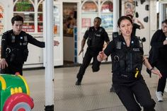
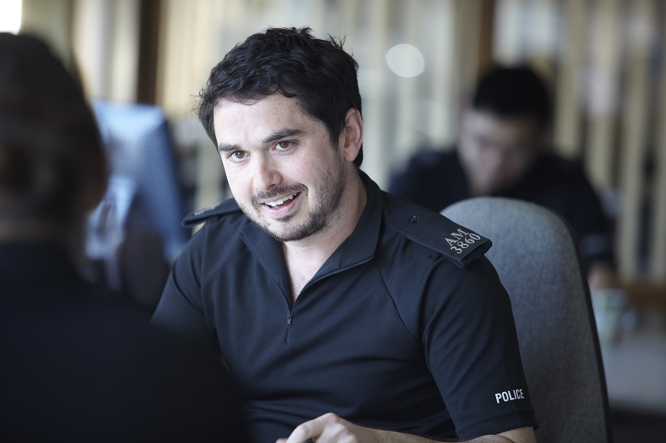
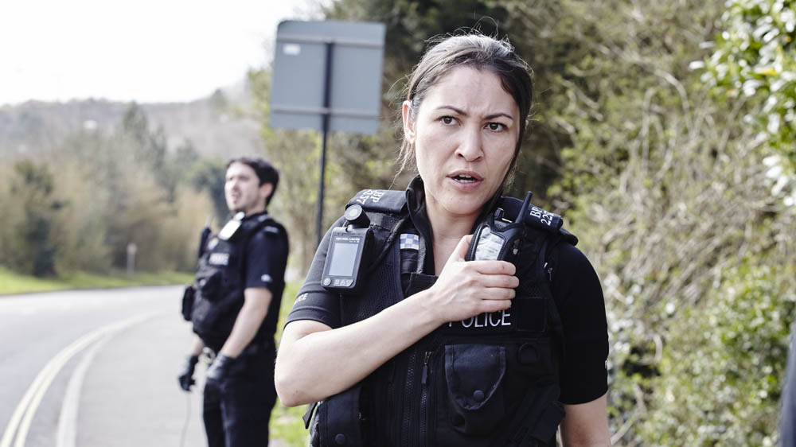
6. Institution: Facts, Facts, Facts!!!
What do we mean by Institutuion? A large media corporation or company. For example ITV or the BBC.
Watershed - is the time before 9pm on television. It is in place to protect younger audience members from offensive material, such as swearing, sex and violence. Any show shown after 9pm is referred to as post-watershed. Think about ‘Cuffs’ on at 8pm – what may it have to cin sider and change about the content? Give egs.
Intertextuality- is when one media text refers to another. Universal audience A universal audience is a wide audience which includes everyone. Everyone will like the product/media text.
Public Service Broadcaster (PSB) Any terrestrial channel. BBC 1, BBC 2, ITV 1, Channel 4 and Channel 5. These channels must follow particular charters to make the audience happy; such as the BBC ‘to inform, to entertain and to educate’ its 15-29 year old target audience. You should show an understanding of the two channels studied and why audiences enjoy watching TV Crime Drama .Think about why ‘The Avengers’ and ‘Cuffs’ are pre-watershed and how that affects the content/portrayal of events. Why are they shown on particular channels and on particular days/timeslots?
ITV The Avengers ‘The Town of No Return’ Episode 1 Series Saturdays 9.05pm 1965 -7 million viewers

BBC 1 Cuffs Episode 1 series 1 ‘The Luck of the Draw’ Wednesdays (aired 28th October) 8pm 2015 -5.5 million viewers

Audience:
You should also demonstrate your awareness of audience and when/why they watch television and how this effects the scheduling of programmes.
What pleasures do the episodes offer their audiences? You will be expected to not only be ablet o name pleasures that all dramas offer but pleasures the set episodes offer specifically, depending on their audience.
Audience pleasures of TV Crime Dramas:
- Regular timeslot
- The narrative and problems are always resolved at the end of the programme Intertextuality
- Relatable characters and situations
- Audience escapism
- Easy to watch (30 minutes long and self-contained episodes mean audience can ‘dip’ in and out of series).
- Pleasure gained from resolution at the end of episode
- Familiarity (e.g. get to know charcters and how they behave)
- Predictability – For example: audiences know character well and know how they will react.
Pick two pleasures ‘The Avengers’ Town of No Return offers: a).........................................................................................................................................................................b).........................................................................................................................................................................
Pick two pleasures ‘Cuffs’ The Luck of the Draw offers: a).........................................................................................................................................................................b).........................................................................................................................................................................
Practise Questions and example answers
See added pages – specimen papers and exemplar answers from exam board.

Other sources of help
OCR website
GoogleClassroom
Your notes in your exercise book from Year 10 and 11
Mock Exam and feedback
Your teacher

